**Luke Dynes- CEO**

**George Rosser- VP**

**Ali Sleiman- Chief Engineer**

**Jacob Soler- CFO**

**Hunter Goffinett- Lead Mechanical**

Christian Miller

Reece Anderson

Sebastian Miller

Garrett Stinett

Carter Persall

Daniel Driver

Laurence Smith

**Casper Casey- Lead Electrical**

Sean Thornton

Addison Barrow

Kai Battle

Jonathan Clements

DeZharious Richard

**Marcus Eiras- Lead Programmer**

Emily Wirth

Megan Stewart

Brandon Nguyen

Danielle Marshall

Hailey Tipton

**Thomas Little- Lead Fabrication**

Nick McNeal

Skyler Raemhild

**Logan Calhoun- Safety Captain**

**Samuel Yachishian- Scout**

Lizzy Wilson

Adam Mangrum

Steven Douglas

Kelela Roe

**Sparkman Engineering Academy**

**Our Mission:**

**Employ research to advance scientific and engineering knowledge to create leaders who excel academically, succeed professionally and positively impact the community.**

**Our Vision:**

**Provide a challenging learning environment in STEM to maximize the potential of individuals to be well-equipped and meet the challenges they will face in the world around them.**

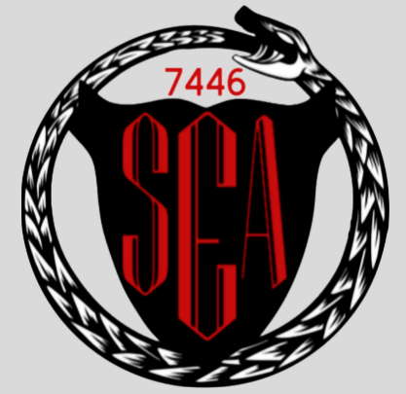

**S.E.A. Monsters**

**Team 7446**

**Sparkman High School**

**2616 Jeff Road**

**Harvest, AL**

**Community Outreach**

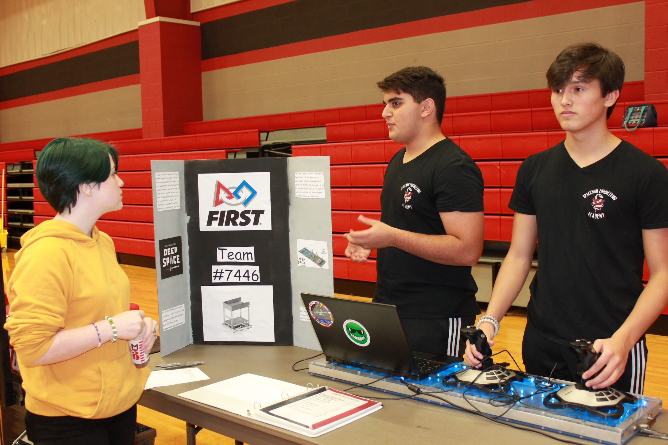

**S9 STEM Expo**

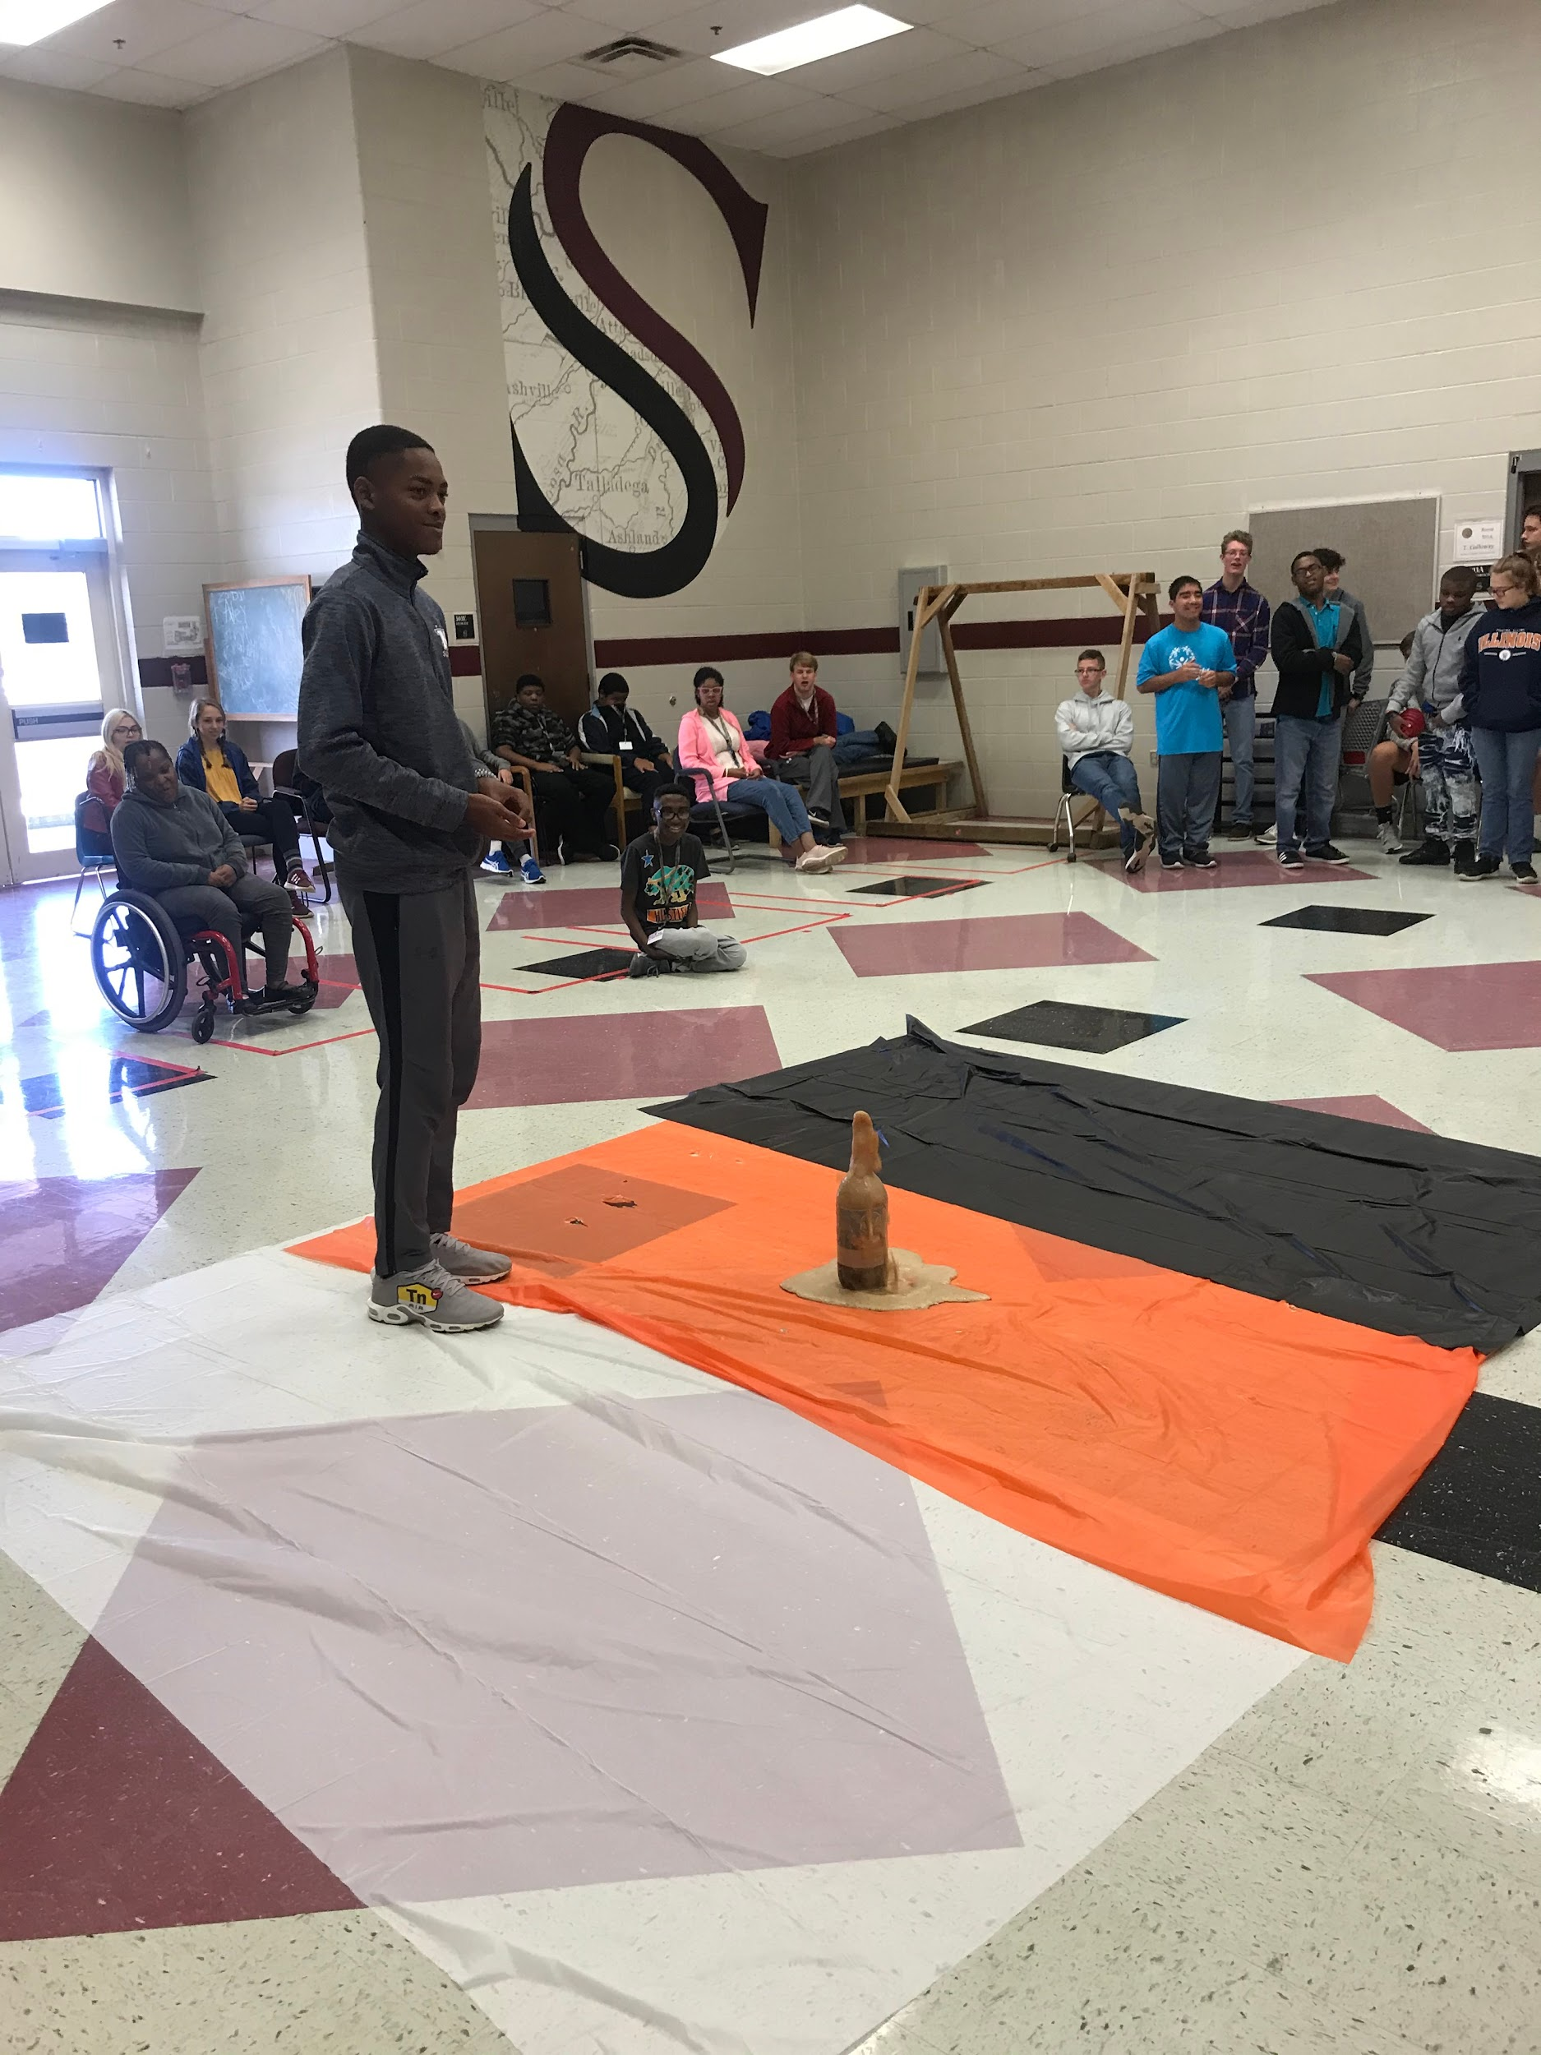

**SLC STEM Day**

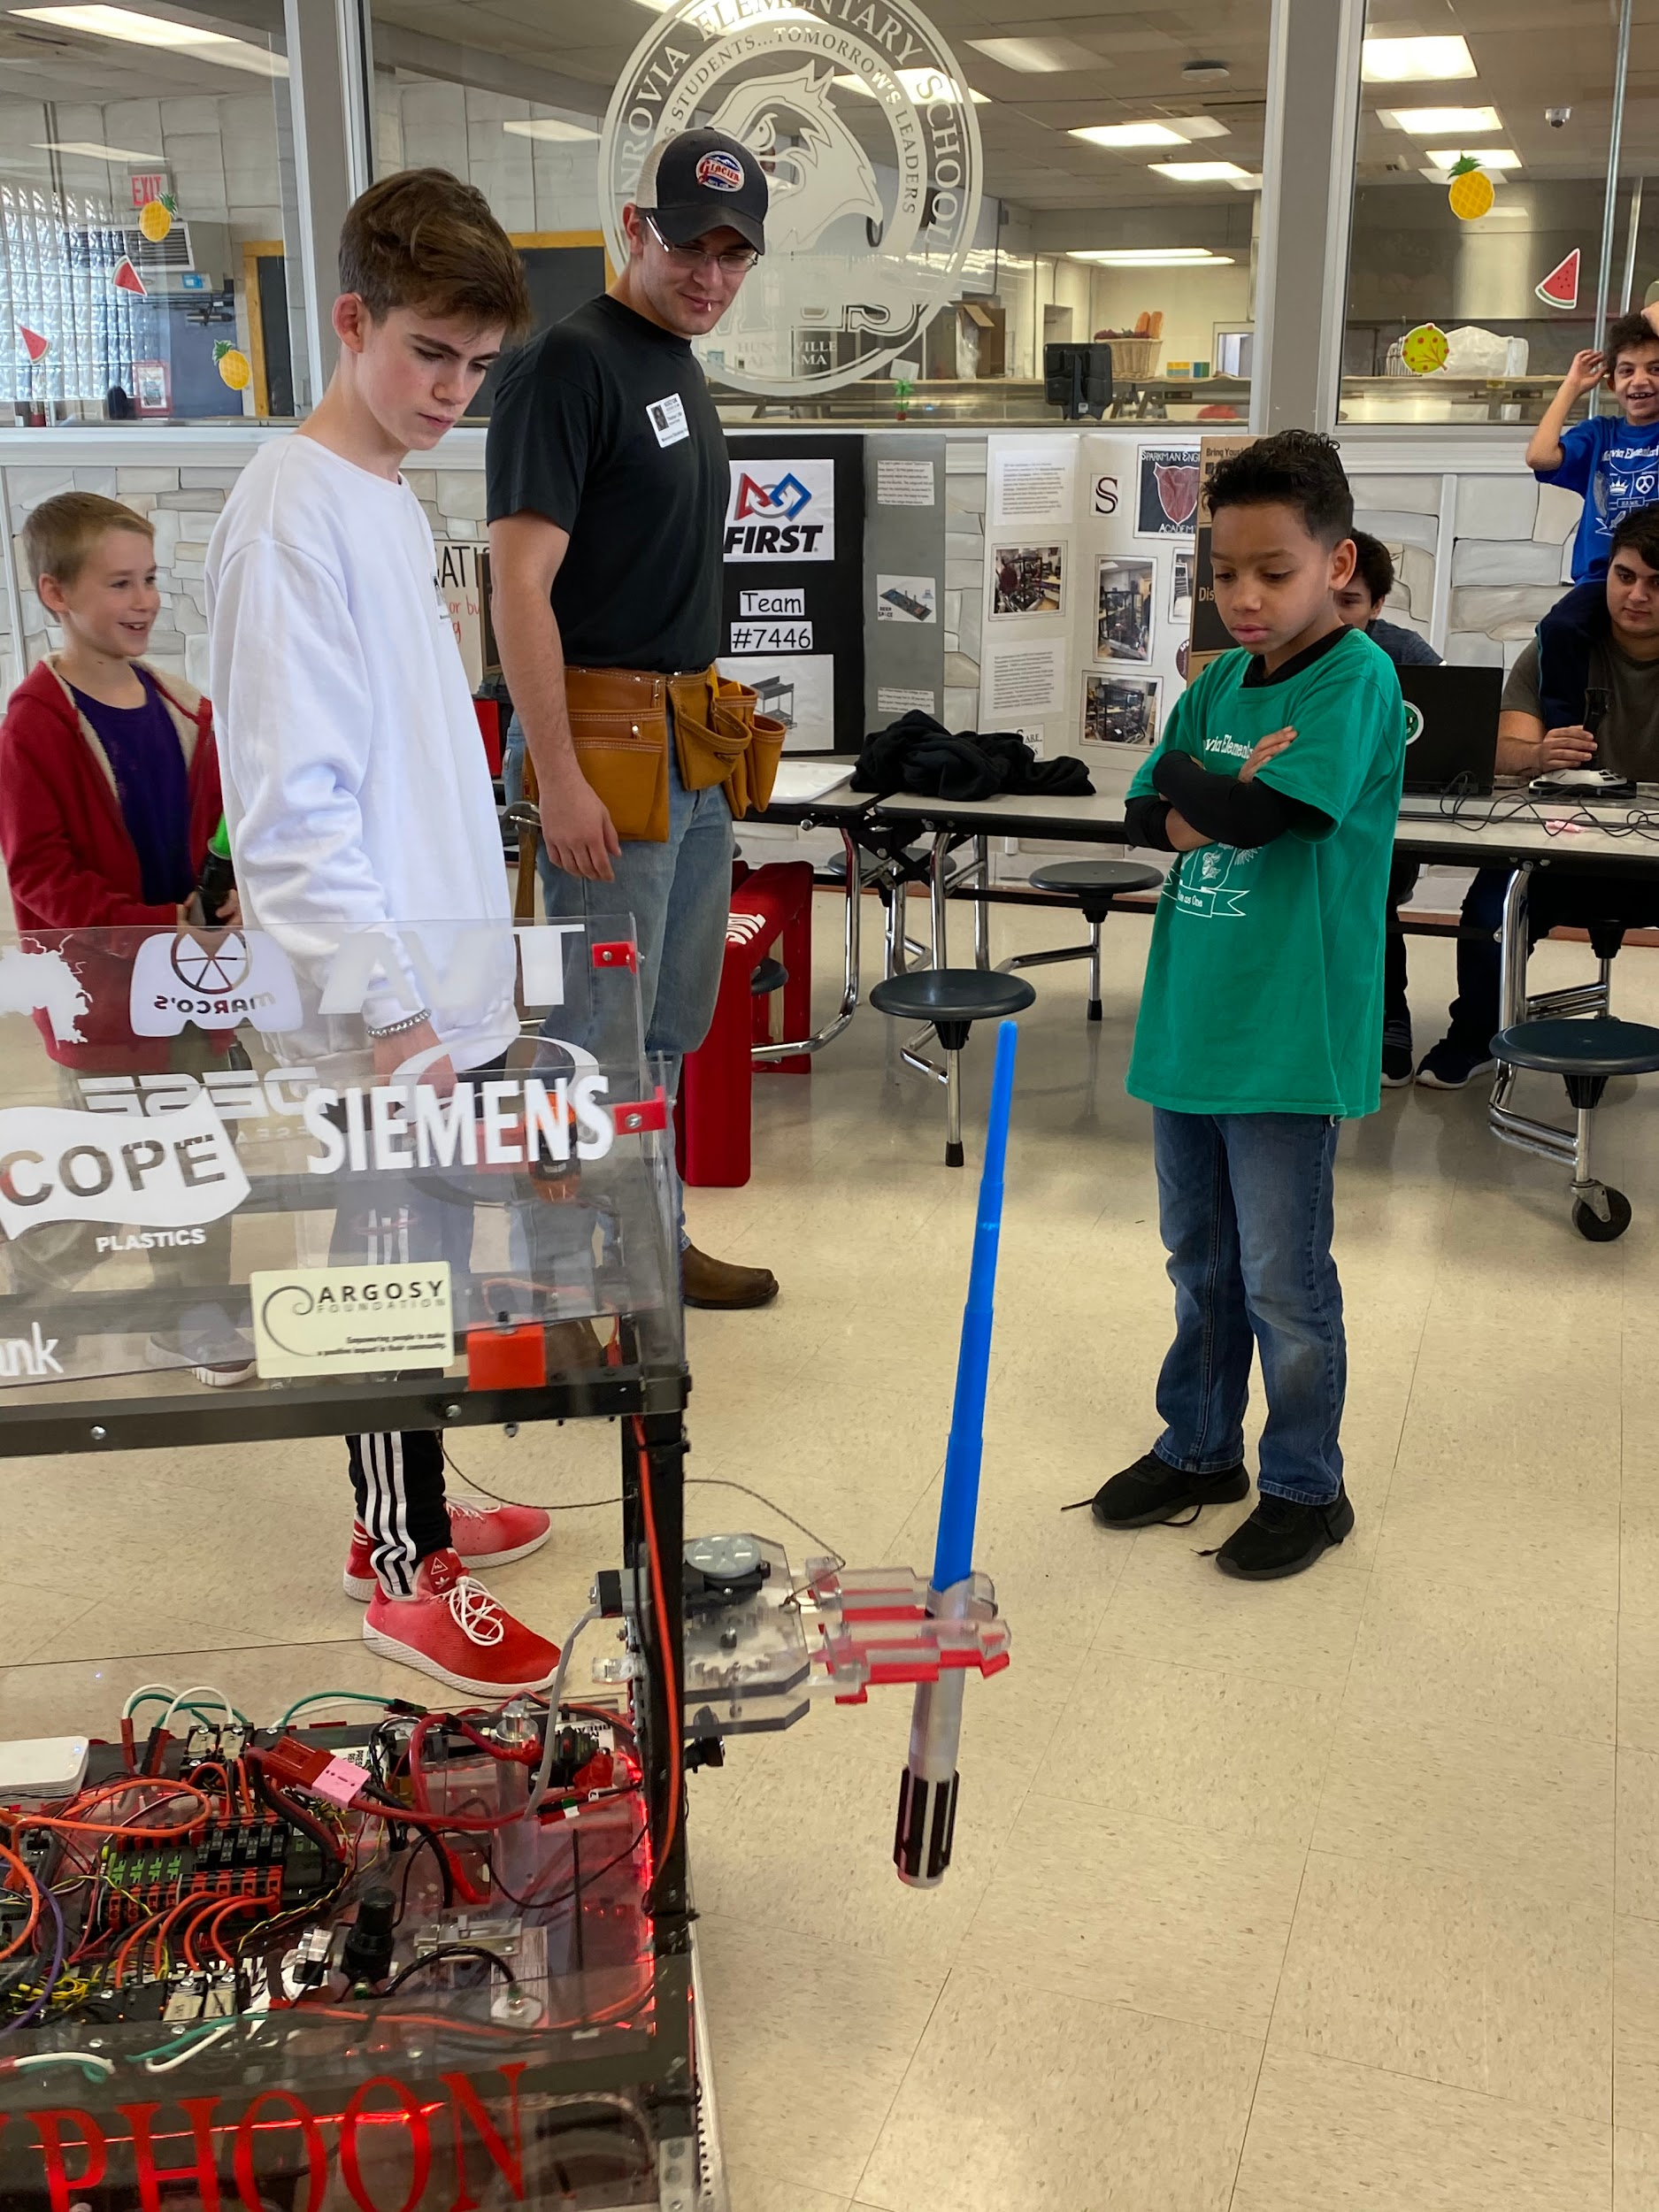

**Monrovia Elementary STEM Day**



**Rookie Season**

**2019**

**Rocket City Regional**

**Rookie All Star**

**Highest Rookie Seed**

**Houston Championship**

**Galileo Division**

**Alliance 8**

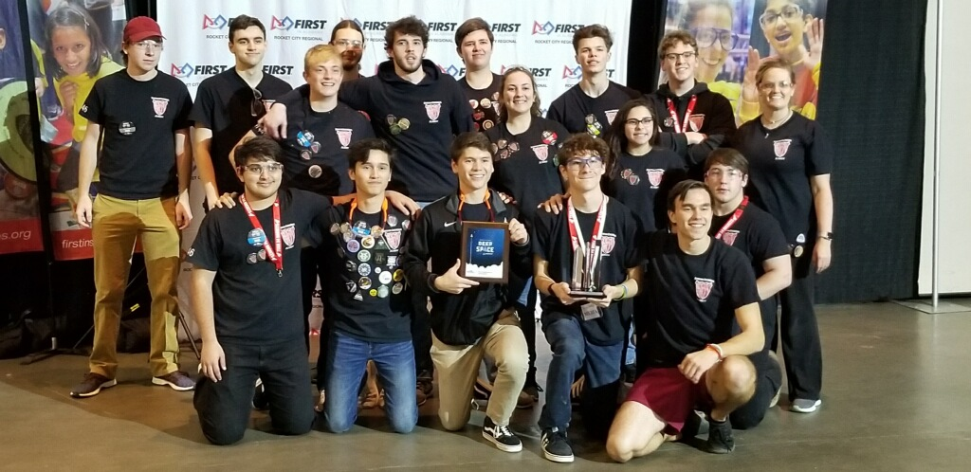

**Thank you to our sponsors!**

